**TABLE OF CONTENTS**

|  |  |  |
| --- | --- | --- |
| **SL. No** | **Topic** | **Page No** |
| **1**.  1.1  1.2  **2**  2.1  2.2  2.3  2.4  **3**  3.1  3.2  **4**  4.1  4.2  **5**  5.1  5.2  5.3  **6**  6.1  6.2  **7**  **8**  **9**  **10**  **11**  11.1  11.2  11.3 | **Introduction**  Problem Definition Problem Description  **System Study**  Existing System Feasibility Study Proposed System  Gantt Chart  **System Design**  ER Diagram,  DFD [lev 0, lev 1]  **System Configuration**  Hardware Requirements  Software Requirements  **Details of Software**  Overview of Frontend Overview of Backend System Maintenance  **System Design**  Architectural Design Input / Output Design  **Testing Implementation**  **Conclusion and Future Enhancement Bibliography**  **APPENDICES**  Table Structure  Screenshots  Sample Report of test cases | **2-3**  **3**  **3**  **4-7**  **5**  **5**  **6**  **7**  **8-16**  **9-13**  **14-16**  **17-18**  **18**  **18**  **19-23**  **20-21**  **21-23**  **22-23**  **24-48**  **25**  **25-48**  **49-51**  **52-54**  **55-56**  **57-58**  **59-68**  **60-61**  **62-64**  **65-68** |

**CHAPTER 1:**

**INTRODUCTION**

**1.INTRODUCTION**

**1.1 Problem Definition**

The gym management system aims to automate administrative tasks such as member and trainer registration, payment processing, and BMI calculation. Through a secure login system, authorized personnel can access features like managing trainer details and registering new members. The system facilitates efficient data management with database integration, ensuring integrity and reliability. Users can generate reports for administrative purposes, enhancing decision-making and record-keeping. Designed with a user-friendly interface, the system aims to streamline operations and improve overall efficiency in managing gym facilities.

**1.2 Problem Description**

The gym management system addresses the challenge of organizing and streamlining various tasks associated with running a gym facility. By automating processes such as member registration, trainer management, and payment processing, the system aims to reduce manual effort and minimize errors. It provides a user-friendly interface for easy navigation and interaction, enhancing user experience. With features like BMI calculation and receipt generation, the system caters to the diverse needs of gym administrators and members alike. By ensuring data integrity and security measures, it maintains confidentiality and trust. Overall, the gym management system optimizes operational efficiency, enabling administrators to focus more on delivering quality services to members.

**CHAPTER 2:**

**SYSTEM STUDY**

**1.SYSTEM STUDY**

**2.1 Existing System**

In the current manual system, gym management relies on paper records for tasks such as member registration, trainer management, and payment processing. This method is time-consuming, prone to errors, and lacks automation for tasks like generating reports and BMI calculation. Security risks exist with physical records, and accessibility to information is limited. Overall, the manual system lacks efficiency and effectiveness, highlighting the need for a computerized gym management system.

**2.2 Feasibility Study**

The basic idea behind feasibility study is to determine whether the project is feasible or not. Feasibility is conducted to identify a best system that meets all the requirements. This includes an identification, description, an evaluation of the proposed systems and selection of the best system for the job. The requirements of the system are specified with a set of constraints such as system objectives and the description of the out puts. It is then duty of the analyst to evaluate the feasibility of the proposed system to generate the above results. Three key factors are to be considered during the feasibility study.

**2.3.1 Operational Feasibility**

The software is developed with a focus on user-friendliness, utilizing VB.NET for the frontend to ensure easy navigation and data management. This section evaluates how the software will integrate into daily operations, the extent of training required for users, and the organization's readiness for adoption. The aim is to minimize operational disruptions and enhance efficiency through the software's implementation.

**2.3.2 Technical Feasibility**

The Gym Management Software underwent a comprehensive technical evaluation, focusing on the organization's technological capabilities. SQL Server Management Studio was chosen for its advanced data management features, ensuring system robustness. Pre-development analysis confirmed adequate computing resources, affirming the project's technical feasibility.

Top of Form

**2.3.3 Economic Feasibility**

Economic Feasibility The project demonstrates strong economic viability through a comprehensive cost-benefit analysis. Initial investment in development and implementation is offset by long-term cost savings, including reduced administrative expenses and improved resource allocation. Anticipated return on investment (ROI) includes potential revenue growth through enhanced member satisfaction and retention. Overall, the economic feasibility indicates that the benefits outweigh the costs, making it a worthwhile investment for the gym facility.

**2.3 Proposed System**

To address the complexities of managing gym operations, the Gym Management System provides an integrated solution tailored to the needs of administrators and members. This system facilitates efficient management of trainer and member profiles, membership plans, and payment processing. A standout feature is the BMI calculator, empowering members to monitor their fitness journey conveniently. Moreover, the system automates receipt generation post-payment, including essential details like membership plan and payment amount. By centralizing data and automating tasks, it enhances operational efficiency and member satisfaction, ensuring smooth gym management without manual errors.

**2.4 Gantt Chart**

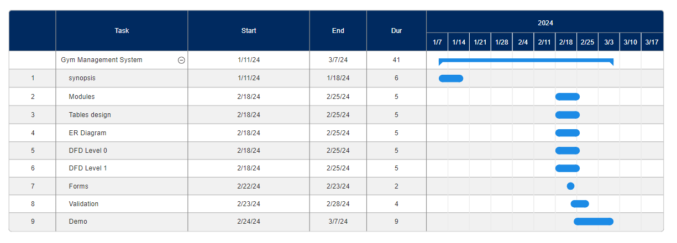

**CHAPTER 3:**

**SYSTEM DESIGN**

**3. ER DIAGRAM, DFD [LVL 0, LVL 1]:**

**3.1 ER Diagram:**

Entity relationship model defines the conceptual view of database. It works around real-world entity and association among them. At view level, ER model is considered well for designing databases.

**Entity:**

A real-world thing either animate or inanimate that can be easily identifiable and distinguishable. For example, in a school database, student, teachers, class and course offered can be considered as entities. All entities have some attributes or properties that give them their identity

An entity set is a collection of similar types of entities. Entity set may contain entities with attribute sharing similar values. For example, Students set may contain all the student of a school; likewise, Teachers set may contain all the teachers of school from all faculties. Entities sets need not to be disjoint

**Attributes:**

Entities are represented by means of their properties, called attributes. All attributes have values. For example, a student entity may have name, class, age as attributes.

There exists a domain or range of values that can be assigned to attributes. For example, a student's name cannot be a numeric value. It has to be alphabetic. A student's age cannot be negative, etc.

An entity–relationship model (ER model) describes inter-related things of interest in a specific domain of knowledge. An ER model is composed of entity types (which classify the things of interest) and specifies relationships that can exist between instances of those entity types.

In software engineering an ER model is commonly formed to represent things that a business needs to remember in order to perform business processes. Consequently, the ER model becomes an abstract data model that defines a data or information structure that can be implemented in a database, typically a relational database

Entity–relationship modeling was developed for database design by Peter Chen and published in a 1976 paper. However, variants of the idea existed previously, some ER modelers show super and subtype entities connected by generalization-specialization relationships, and an ER model can be used also in the specification of domain-specific ontology.

**3.1.1 Steps – How to Draw ER Diagram**

1. Identify all the entities of the given problem.
2. Identify all the attributes of the entities identified in step 1.
3. Identify the Primary Keys of entities identified in Step 1.
4. Identify the Attribute Types of attributes identified in step 2
5. Identify relationship between the entities and constraints on the entities

and implement them.

**3.1.2 Entity Relationship Diagram Symbols and descriptions:**

|  |  |  |
| --- | --- | --- |
| **Symbol** | **Name** | **Description** |
| ERD Symbols and Meaning - Entity | Entity | An entity is represented by a rectangle which contains the entity’s name. |
| ERD Symbols and Meaning - Weak Entity | Weak entity | An entity that cannot be uniquely identified by its attributes alone. The existence of a weak entity is dependent upon another entity called the owner entity. The weak entity’s identifier is a combination of the identifier of the owner entity and the partial key of the weak entity. |
| ERD Symbols and Meaning - Associative Entity | Associative Entity | An entity used in a many-to- many relationship (represents an extra table). All relationships for the associative entity should be many |
| ERD Symbols and Meaning - Attribute | Attribute | In the Chen notation, each attribute is represented by an oval containing attribute’s name |

|  |  |  |
| --- | --- | --- |
| ERD Symbols and Meaning - Key attribute | Key Attribute | An attribute that uniquely identifies a particular entity. The name of a key attribute is underscored. |
| ERD Symbols and Meaning - Multivalue attribute | Multi-value Attribute | An attribute that can have many values (there are many distinct values entered for it in the same column of the table). Multi- valued attribute is depicted by a dual oval. |
| ERD Symbols and Meaning - Derived attribute | Derived Attribute | An attribute whose value is calculated (derived) from other attributes. The derived attribute may or may not be physically stored in the database. In the Chen notation, this attribute is represented by dashed oval. |
| ERD Symbols and Meaning - Relationship | Strong Relationship | A relationship where entity is existence-independent of other entities and PK of Child doesn’t contain PK component of Parent Entity. A strong relationship is represented by a single rhombus |
| ERD Symbols and Meaning - Identifying Relationship | Weak Relationship | A relationship where Child entity is existence-dependent on parent and PK of Child Entity contains PK component of Parent Entity. This relationship is represented by a double rhombus. |

**3.1.3 ER Diagram of Gym Management System:**

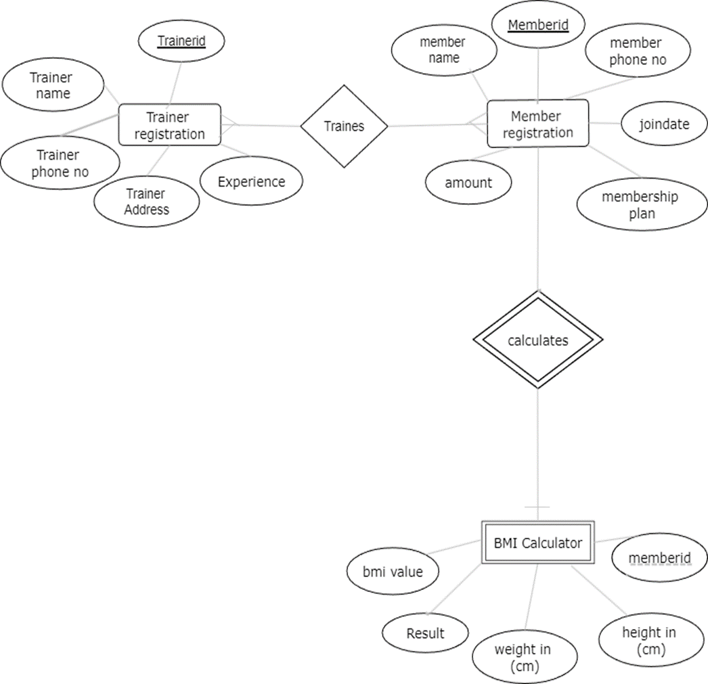

**3.2 Data Flow Diagram:**

A data flow diagram (DFD) is a graphical representation of the "flow" of data through an information system, modelling its process aspects. A DFD is often used as a preliminary step to create an overview of the system, which can later be elaborated. DFDs can also be used for the visualization of data processing (structured design).

A DFD shows what kind of information will be input to and output from the system, where the data will come from and go to, and where the data will be stored. It does not show information about the timing of process or information about whether processes will operate in sequence or in parallel (which is shown on a flowchart).

A DFD shows what kind of information will be input to and output from the system, where the data will come from and go to, and where the data will be stored. It does not show information about the timing of process or information about whether processes will operate in sequence or in parallel

It is common practice to draw the context-level data flow diagram first, which shows the interaction between the system and external agents which act as data sources and data sinks. This helps to create an accurate drawing in the context diagram. The system's interactions with the outside world are modelled purely in terms of data flows across the system boundary. The context diagram shows the entire system as a single process, and gives no clues as to its internal organization

**3.2.1 DFD Symbols and meanings:**

|  |  |  |
| --- | --- | --- |
| **Symbol** | **Meaning** | **Example** |
|  | An entity. A source of data or a destination for data. | Employee |
|  | A process or task that is performed by the system. | Registration |
|  | A data store, a place where data is held between processes. | Employee Database |
|  | A data flow | Authentication |

**3.2.2 DFD level 0:**

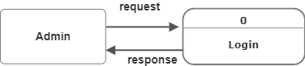

**3.2.2 DFD level 1:**

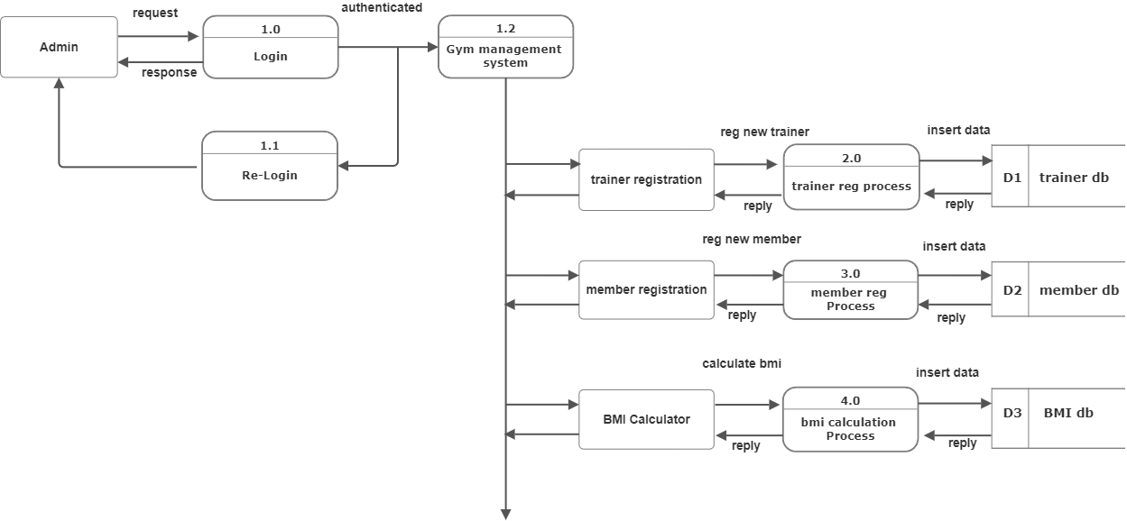

**CHAPTER 4:**

**SYSTEM CONFIGURATION**

**2.SYSTEM CONFIGURATION**

**4.1 HARDWARE REQUIREMENTS**

|  |  |
| --- | --- |
| **Processor** | intel i3(dual core) or above |
| **Clock speed** | 4.00GHz |
| **Ram** | 4gb or more |
| **hdd** | 50gb |
| **Monitor** | SVGA color |
| **Key board** | 101 keys |
| **Mouse** | ps2/ serial |

**4.2 SOFTWARE REQUIREMENTS**

|  |  |
| --- | --- |
| **Operating System** | Windows 10 |
| **Programming Language** | VB.net |
| **Database** | SQL Server 2019 |
| **Tool** | Visual Studio 2022 |

**CHAPTER 5:**

**DETAILS OF SOFTWARE**

**5. DETAILS OF SOFTWARE**

**5.1 Overview of frontend**

Introduction To the .Net Framework:

The .NET Framework is a new computing platform that simplifies application development in the highly distributed environment of the Internet. The .NET Framework is designed to fulfil the following objectives:

* To provide a consistent object-oriented programming environment whether object code is stored and executed locally, executed locally but Internet-distributed, or executed remotely.
* To provide a code-execution environment that minimizes software deployment and versioning conflicts.
* To provide a code-execution environment that guarantees safe execution of code, including code created by an unknown or semi-trusted third party.
* To provide a code-execution environment that eliminates the performance problems of scripted or interpreted environments.
* To make the developer experience consistent across widely varying types of applications, such as Windows-based applications and Web-based applications.
* To build all communication on industry standards to ensure that code based on the

.NET Framework can integrate with any other code.

The .NET Framework has two main components: the common language runtime and the .NET Framework class library. The common language runtime is the foundation of the .NET Framework. You can think of the runtime as an agent that manages code at execution time, providing core services such as memory management, thread management while also enforcing strict type safety and other forms of code accuracy that ensure security and robustness. In fact, the concept of code management is a fundamental principle of the runtime. Code that targets the runtime is known as managed code, while code that does not target the runtime is known as unmanaged code. The class library, the other main component of the .NET Framework,

is a comprehensive, object-oriented collection of reusable types that you can use to develop applications ranging from traditional command-line or graphical user interface (GUI) applications to applications based on the latest innovations provided by ASP.NET, such as Web Forms and XML Web services

**5.2 Overview of backend**

**5.2.1 SQL server:**

A database management, or DBMS, gives the user access to their data and helps them transform the data into information. Such database management systems include dBase, paradox, IMS, SQL Server and SQL Server. These systems allow users to create, update and extract information from their database.

A database is a structured collection of data. Data refers to the characteristics of people, things and events. SQL Server stores each data item in its own fields. In SQL Server, the fields relating to a particular person, thing or event are bundled together to form a single complete unit of data, called a record (it can also be referred to as raw or an occurrence). Each record is made up of a number of fields. No two fields in a record can have the same field name.

During an SQL Server Database design project, the analysis of your business needs identifies all the fields or attributes of interest. If your business needs change over time, you define any additional fields or change the definition of existing fields

**5.2.2 SQL server tables:**

SQL Server stores records relating to each other in a table. Different tables are created for the various groups of information. Related tables are grouped together to form a database.

**5.2.3 Primary key:**

Every table in SQL Server has a field or a combination of fields that uniquely identifies each record in the table. The Unique identifier is called the Primary Key, or simply the Key. The primary key provides the means

to distinguish one record from all other in a table. It allows the user and the database system to identify, locate and refer to one particular record in the database.

**5.2.4 Relational database:**

Sometimes all the information of interest to a business operation can be stored in one table. SQL Server makes it very easy to link the data in multiple tables. Matching an employee to the department in which they work is one example. This is what makes SQL Server a relational database management system, or RDBMS. It stores data in two or more tables and enables you to define relationships between the tables and enables you to define relationships between the tables.

**5.2.5 Foreign key:**

When a field is one table matches the primary key of another field is referred to as a foreign key. A foreign key is a field or a group of fields in one table whose values match those of the primary key of another table.

**5.2.6 Referential integrity:**

Not only does SQL Server allow you to link multiple tables, it also maintains consistency between them. Ensuring that the data among related tables is correctly matched is referred to as maintaining referential integrity

### **5.3 System Maintenance and Evaluation:**

System maintenance is the process of modifying software product after it is delivered to the customer. Software maintenance is inevitable as it is subjected to wear and tear.

* It is necessary to rectify some errors in the system or increase the performance of the system. This is done by corrective maintenance.
* If the customer demand that their product has to run on new platform then adoptive maintenance is required. It is also applied when the system has to interface with new hardware or software.
* It helps to support new system features. The users can change different functions of the system.

The project is developed using the Water fall model. It suggests the systematic and sequential approach to software development. Waterfall model is the oldest and most widely used process model. Each phase of the life cycle is completed before the start of a new phase. It is the engineering approach. The waterfall model makes the project:

* + Simple in nature.
  + Easy to implement.
  + Systematic approach.
  + It is an essential approach to software development.

**CHAPTER 6:**

**SYSTEM DESIGN**

1. **SYSTEM DESIGN**

**6.1 Architectural Design**

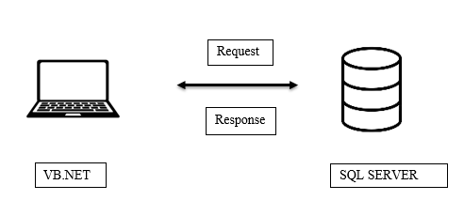

**6.2 Input /Output Design:**

The design of input focuses on controlling the amount of input required, controlling the errors, avoiding delay, avoiding extra steps and keeping the process simple. The input is designed in such a way so that it provides security and ease of use with retaining the privacy.

**6.2.1 Input Design:**

Input Design is the process of converting a user-oriented description of the input into a computer-based system. This design is important to avoid errors in the data input process and show the correct direction to the management for getting correct information from the computerized system.

It is achieved by creating user-friendly screens for the data entry to handle large volume of data. The goal of designing input is to make data entry easier and to be free from errors. The data entry screen is designed in such a way that all the data manipulates can be performed. It also provides record viewing facilities.

When the data is entered it will check for its validity. Data can be entered with the help of screens. Appropriate messages are provided as when needed so that the user will not be in a maize of instant. Thus, the objective of input design is to create an input layout that is easy to follow.

Below are VB.NET codes used in the development of the project:

**Login Page**

Public Class Form1

Private Sub Form1_Load(sender As Object, e As EventArgs) Handles MyBase.Load

ProgressBar1.Minimum = 0

ProgressBar1.Maximum = 100

ProgressBar1.Value = 0

Me.WindowState = FormWindowState.Maximized

End Sub

Private Sub Button1_click(sender As Object, e As EventArgs) Handles Button1.Click

If TextBox1.Text = "" AndAlso TextBox2.Text = "" Then

' Display a message indicating both fields are empty

MessageBox.Show("Please enter username and password")

ElseIf TextBox1.Text = "" Then

' Display a message indicating username is empty

MessageBox.Show("Please enter username")

ElseIf TextBox2.Text = "" Then

' Display a message indicating password is empty

MessageBox.Show("Please enter password")

ElseIf TextBox1.Text = "kjc" AndAlso TextBox2.Text = "abc" Then

' Simulate a login process (replace this with your actual login logic)

Dim username As String = TextBox1.Text

Dim password As String = TextBox2.Text

' Display a message indicating successful login

MessageBox.Show("Login Successful")

' Open the next form

Dim form2 As New Form2

form2.Show()

' Close this form after the next form is closed

Me.Hide()

Else

' Display a message indicating unsuccessful login

MessageBox.Show("Invalid username or password")

End If

End Sub

Private Sub Button2_click(sender As Object, e As EventArgs) Handles Button2.Click

TextBox1.Text = ""

TextBox2.Text = ""

ProgressBar1.Value = 0

End Sub

Private Sub CheckBox2_CheckedChanged(sender As Object, e As EventArgs) Handles CheckBox2.CheckedChanged

If CheckBox2.Checked = True Then

TextBox2.UseSystemPasswordChar = False

Else

TextBox2.UseSystemPasswordChar = True

End If

End Sub

Private Sub PictureBox1_Click(sender As Object, e As EventArgs) Handles PictureBox1.Click

End Sub

Private Sub TextBox1_KeyPress(ByVal sender As Object, ByVal e As System.Windows.Forms.KeyPressEventArgs) Handles TextBox1.KeyPress

' Check if Enter key was pressed

If e.KeyChar = Microsoft.VisualBasic.ChrW(Keys.Enter) Then

' Set focus to the next control

Me.SelectNextControl(sender, True, True, True, True)

End If

End Sub

Private Sub TextBox2_KeyPress(ByVal sender As Object, ByVal e As System.Windows.Forms.KeyPressEventArgs) Handles TextBox2.KeyPress

' Check if Enter key was pressed

If e.KeyChar = Microsoft.VisualBasic.ChrW(Keys.Enter) Then

' Set focus to the next control

Me.SelectNextControl(sender, True, True, True, True)

End If

End Sub

Private Sub Button3_Click(sender As Object, e As EventArgs) Handles Button3.Click

Application.Exit()

End Sub

End Class

**Dashboard**

Public Class Form2

Private Sub Button1_Click(sender As Object, e As EventArgs) Handles Button1.Click

Form3.Show()

End Sub

Private Sub Button2_Click(sender As Object, e As EventArgs) Handles Button2.Click

Form4.Show()

End Sub

Private Sub Button3_Click(sender As Object, e As EventArgs) Handles Button3.Click

MessageBox.Show("YOU CAN'T ACCESS BMI WITHOUT REGISTERING ")

End Sub

Private Sub Button4_Click(sender As Object, e As EventArgs) Handles Button4.Click

Dim form1 As New Form1

form1.Show()

Me.Close()

Form1.ProgressBar1.Value = 0

Form1.TextBox1.Text = ""

Form1.TextBox2.Text = ""

End Sub

Private Sub Form2_Load(sender As Object, e As EventArgs) Handles MyBase.Load

Me.WindowState = FormWindowState.Maximized

End Sub

End Class

**Trainer Registration**

Imports System.Data.SqlClient

Imports System.Text.RegularExpressions

Public Class Form3

Private Sub Button3_click(sender As Object, e As EventArgs) Handles Button3.Click

Me.Close()

End Sub

Private Sub Button2_Click(sender As Object, e As EventArgs) Handles Button2.Click

TextBox2.Text = ""

TextBox3.Text = ""

TextBox4.Text = ""

ComboBox2.Text = ""

End Sub

Private Sub Textbox3_keypress(sender As Object, e As KeyPressEventArgs) Handles TextBox3.KeyPress

If TextBox3.Text.Length = 10 Then

If e.KeyChar <> ControlChars.Back Then

e.Handled = True

MessageBox.Show("THIS FIELD ACCEPTS ONLY 10 DIGITS 🔢")

End If

End If

If Not Char.IsControl(e.KeyChar) AndAlso Not Char.IsDigit(e.KeyChar) Then

e.Handled = True

End If

' Allowing only digits, backspace, and delete

If Not Char.IsDigit(e.KeyChar) AndAlso e.KeyChar <> ControlChars.Back AndAlso e.KeyChar <> Chr(Keys.Delete) Then

e.Handled = True

MessageBox.Show("THIS FIELD ACCEPTS ONLY NUMERIC INPUT 🔢.")

End If

End Sub

Private Sub TextBox2_KeyPress(sender As Object, e As KeyPressEventArgs) Handles TextBox2.KeyPress

If Not Char.IsLetter(e.KeyChar) AndAlso Not e.KeyChar = Chr(Keys.Delete) AndAlso Not e.KeyChar = Chr(Keys.Back) Then

e.Handled = True

MessageBox.Show("THIS FIELD ALLOWS ONLY LETTERS 🔠")

End If

End Sub

Private Sub TextBox1_KeyPress(sender As Object, e As KeyPressEventArgs) Handles TextBox1.KeyPress

' Set e.Handled to True to prevent editing or backspacing in TextBox1

e.Handled = True

End Sub

Private Sub Form3_Load(sender As Object, e As EventArgs) Handles MyBase.Load

' Fetch the last Trainer ID from the database and auto-generate the next Trainer ID

FetchLastTrainerID()

Me.WindowState = FormWindowState.Maximized

' Set ComboBox1 to non-editable

ComboBox2.DropDownStyle = ComboBoxStyle.DropDownList

End Sub

Private Sub FetchLastTrainerID()

Try

Dim connectionString As String = "Data Source=LAPTOP-LLE7RUDV\SQLEXPRESS;Initial Catalog=gym db;Integrated Security=True"

Using connection As New SqlConnection(connectionString)

connection.Open()

Dim query As String = "SELECT MAX([TRAINER ID]) FROM [Trainer registration]"

Using command As New SqlCommand(query, connection)

Dim result As Object = command.ExecuteScalar()

If result IsNot DBNull.Value Then

Dim lastTrainerID As Integer = Convert.ToInt32(result)

TextBox1.Text = (lastTrainerID + 1).ToString("D6")

Else

TextBox1.Text = "123456"

End If

End Using

End Using

Catch ex As Exception

MessageBox.Show("Error fetching Trainer ID: " & ex.Message)

End Try

End Sub

Private Sub Button1_Click(sender As Object, e As EventArgs) Handles Button1.Click

If TextBox1.Text = "" Or TextBox2.Text = "" Or TextBox3.Text = "" Or TextBox4.Text = "" Or ComboBox2.Text = "" Then

MessageBox.Show("PLEASE FILL IN ALL REQUIRED FIELD 😊!")

Exit Sub

End If

' Check if Trainer ID contains exactly 6 digits

If TextBox1.Text.Length <> 6 Then

MessageBox.Show("TRAINER ID SHOULD CONTAIN EXACTLY 6 DIGITS.")

Exit Sub

End If

' Check if Phone Number contains exactly 10 digits and satisfies the additional constraints

If Not ValidatePhoneNumber(TextBox3.Text) Then

MessageBox.Show("INVALID PHONE NO✖️.")

Exit Sub

End If

' Connection string for your SQL Server

Dim connectionString As String = "Data Source=LAPTOP-LLE7RUDV\SQLEXPRESS;Initial Catalog=gym db;Integrated Security=True"

Try

Using connection As New SqlConnection(connectionString)

connection.Open()

' Check if the Trainer ID already exists

Dim idExistsQuery As String = "SELECT COUNT(*) FROM [Trainer registration] WHERE [TRAINER ID] = @TrainerID"

Using idExistsCommand As New SqlCommand(idExistsQuery, connection)

idExistsCommand.Parameters.AddWithValue("@TrainerID", TextBox1.Text)

Dim idCount As Integer = Convert.ToInt32(idExistsCommand.ExecuteScalar())

If idCount > 0 Then

MessageBox.Show("Trainer ID already exists in the database. Please choose a different ID.")

Exit Sub

End If

End Using

' Check if the Phone Number already exists

Dim phoneExistsQuery As String = "SELECT COUNT(*) FROM [Trainer registration] WHERE [TRAINER PHONE NO] = @TrainerPhoneNo"

Using phoneExistsCommand As New SqlCommand(phoneExistsQuery, connection)

phoneExistsCommand.Parameters.AddWithValue("@TrainerPhoneNo", TextBox3.Text)

Dim phoneCount As Integer = Convert.ToInt32(phoneExistsCommand.ExecuteScalar())

If phoneCount > 0 Then

MessageBox.Show("Phone number already exists in the database. Please enter a different phone number.")

Exit Sub

End If

End Using

' SQL query to insert data into the database

Dim query As String = "INSERT INTO [Trainer registration] ([TRAINER ID], [TRAINER NAME], [TRAINER PHONE NO], [TRAINER ADDRESS], [EXPERIENCE]) VALUES (@TrainerID, @TrainerName, @TrainerPhoneNo, @TrainerAddress, @Experience)"

Using command As New SqlCommand(query, connection)

' Replace @TrainerID, @TrainerName, @TrainerPhoneNo, @TrainerAddress, @Experience with actual parameter names (e.g., TextBox1.Text)

command.Parameters.AddWithValue("@TrainerID", TextBox1.Text)

command.Parameters.AddWithValue("@TrainerName", TextBox2.Text)

command.Parameters.AddWithValue("@TrainerPhoneNo", TextBox3.Text)

command.Parameters.AddWithValue("@TrainerAddress", TextBox4.Text)

command.Parameters.AddWithValue("Experience", ComboBox2.Text)

command.ExecuteNonQuery()

MessageBox.Show("DATA SAVED SUCCESSFULLY 😊.")

' Clear all text boxes and the combo box

TextBox2.Text = ""

TextBox3.Text = ""

TextBox4.Text = ""

ComboBox2.SelectedIndex = -1 ' Reset combo box selection

End Using

End Using

Catch ex As Exception

MessageBox.Show("Error saving data: " & ex.Message)

End Try

End Sub

Shared Function ValidatePhoneNumber(phoneNumber As String) As Boolean

' Check if the phone number starts with 0-5

If Regex.IsMatch(phoneNumber, "^[0-5]") Then

MessageBox.Show("INVALID INPUT")

Return False

End If

' Check if the phone number contains only 10 digits

If Not Regex.IsMatch(phoneNumber, "^\d{10}$") Then

MessageBox.Show("INVALID PHONE NO ❌")

Return False

End If

' Check if the phone number has repeating digits more than 3 times consecutively

If Regex.IsMatch(phoneNumber, "(.)\1{3,}") Then

MessageBox.Show("INVALID PHONE NO ❌ ")

Return False

End If

Return True

End Function

Private Sub ComboBox2_KeyDown(sender As Object, e As KeyEventArgs) Handles ComboBox2.KeyDown

' Suppress the key press event to prevent changing the selected item in ComboBox2 using the keyboard

e.SuppressKeyPress = True

End Sub

Private Sub ComboBox2_SelectedIndexChanged(sender As Object, e As EventArgs) Handles ComboBox2.SelectedIndexChanged

End Sub

Private Sub GroupBox1_Enter(sender As Object, e As EventArgs) Handles GroupBox1.Enter

End Sub

End Class

**Member Registration**

Imports System.Data.SqlClient

Imports System.Text.RegularExpressions

Imports iTextSharp.text

Imports iTextSharp.text.pdf

Imports System.IO

Imports System.Drawing.Printing

Imports System.Windows.Forms.VisualStyles.VisualStyleElement

Public Class Form4

Private Sub PrintMemberDetails()

' Retrieve data from the form controls

Dim memberId As String = TextBox1.Text

Dim memberName As String = TextBox2.Text

Dim phoneNumber As String = TextBox3.Text

Dim joinDate As String = DateTimePicker1.Value.ToString("yyyy-MM-dd")

Dim membershipPlan As String = ComboBox1.SelectedItem?.ToString()

Dim amount As String = TextBox4.Text

' Check if all necessary fields are filled

If Not String.IsNullOrWhiteSpace(memberId) AndAlso

Not String.IsNullOrWhiteSpace(memberName) AndAlso

Not String.IsNullOrWhiteSpace(phoneNumber) AndAlso

Not String.IsNullOrWhiteSpace(joinDate) AndAlso

Not String.IsNullOrWhiteSpace(membershipPlan) AndAlso

Not String.IsNullOrWhiteSpace(amount) Then

' Create a new PDF document

Dim doc As New iTextSharp.text.Document()

Dim directoryPath As String = "C:\PDF Generated"

Dim fileName As String = $"MemberDetails_{memberId}.pdf"

Dim filePath As String = Path.Combine(directoryPath, fileName)

Try

Dim writer As PdfWriter = PdfWriter.GetInstance(doc, New FileStream(filePath, FileMode.Create))

doc.Open()

' Add content to the PDF document

Dim para As New Paragraph()

para.Add("Member ID: " & memberId & vbCrLf)

para.Add("Member Name: " & memberName & vbCrLf)

para.Add("Phone Number: " & phoneNumber & vbCrLf)

para.Add("Join Date: " & joinDate & vbCrLf)

para.Add("Membership Plan: " & membershipPlan & vbCrLf)

para.Add("Amount: " & amount & vbCrLf)

para.Add("Payment Status: Paid" & vbCrLf)

doc.Add(para)

Catch ex As Exception

MessageBox.Show("Error creating PDF: " & ex.Message, "Error", MessageBoxButtons.OK, MessageBoxIcon.Error)

Finally

doc.Close()

End Try

Else

MessageBox.Show("Please fill all member details.", "Error", MessageBoxButtons.OK, MessageBoxIcon.Error)

End If

End Sub

Private form5Instance As Form5

Private paymentDone As Boolean = False ' Variable to track payment status

Private Shared _memberId1 As Integer ' Private shared field

Public Shared Property MemberId1 As Integer ' Public shared property

Get

Return _memberId1

End Get

Set(value As Integer)

_memberId1 = value

End Set

End Property

Private Sub TextBox1_KeyPress(sender As Object, e As KeyPressEventArgs) Handles TextBox1.KeyPress

' Allow only numbers, backspace, and delete

If Not Char.IsNumber(e.KeyChar) AndAlso Not e.KeyChar = Chr(Keys.Back) AndAlso Not e.KeyChar = Chr(Keys.Delete) Then

e.Handled = True

MessageBox.Show("THIS FIELD ALLOWS ONLY NUMBERS 🔢")

End If

' Check if the length of the TextBox is 6

If TextBox1.Text.Replace(" ", "").Length = 6 AndAlso Not Char.IsControl(e.KeyChar) Then

e.Handled = True

MessageBox.Show("MEMBER ID CONTAINS ONLY 6 DIGITS")

End If

End Sub

Private Sub Button3_Click(sender As Object, e As EventArgs) Handles Button3.Click

Me.Close()

End Sub

Private Sub Button2_Click(sender As Object, e As EventArgs) Handles Button2.Click

TextBox4.Text = ""

TextBox2.Text = ""

TextBox3.Text = ""

ComboBox1.Text = ""

paymentDone = False ' Reset payment status

End Sub

Private Sub TextBox3_keypress(sender As Object, e As KeyPressEventArgs) Handles TextBox3.KeyPress

If TextBox3.Text.Length = 10 Then

If e.KeyChar <> ControlChars.Back Then

e.Handled = True

MessageBox.Show("THIS FIELD ACCEPTS ONLY 10 DIGITS 🔢")

End If

End If

If Not Char.IsControl(e.KeyChar) AndAlso Not Char.IsDigit(e.KeyChar) Then

e.Handled = True

End If

' Allowing only digits, backspace, and delete

If Not Char.IsDigit(e.KeyChar) AndAlso e.KeyChar <> ControlChars.Back AndAlso e.KeyChar <> Chr(Keys.Delete) Then

e.Handled = True

MessageBox.Show("THIS FIELD ACCEPTS ONLY NUMERIC INPUT 🔢.")

End If

End Sub

Private Sub Form4_Load(sender As Object, e As EventArgs) Handles MyBase.Load

TextBox3.Text = ""

Me.WindowState = FormWindowState.Maximized

DateTimePicker1.Value = Date.Today

DateTimePicker1.MinDate = Date.Today

DateTimePicker1.MaxDate = Date.Today

ComboBox1.SelectedIndex = -1

' Set ComboBox1 to non-editable

ComboBox1.DropDownStyle = ComboBoxStyle.DropDownList

' Fetch the last member ID from the database and increment it by 1

Try

Dim connectionString As String = "Data Source=LAPTOP-LLE7RUDV\SQLEXPRESS;Initial Catalog=gym db;Integrated Security=True"

Using connection As New SqlConnection(connectionString)

connection.Open()

Dim query As String = "SELECT MAX([MEMBER ID]) FROM [Member registration]"

Using command As New SqlCommand(query, connection)

Dim result As Object = command.ExecuteScalar()

If result IsNot DBNull.Value Then

Dim lastMemberID As Integer = Convert.ToInt32(result)

TextBox1.Text = (lastMemberID + 1).ToString("D6")

Else

TextBox1.Text = "111111"

End If

End Using

End Using

Catch ex As Exception

MessageBox.Show("Error fetching member ID: " & ex.Message)

End Try

End Sub

Private Sub TextBox2_KeyPress(sender As Object, e As KeyPressEventArgs) Handles TextBox2.KeyPress

If Not Char.IsLetter(e.KeyChar) AndAlso Not e.KeyChar = Chr(Keys.Delete) AndAlso Not e.KeyChar = Chr(Keys.Back) Then

e.Handled = True

MessageBox.Show("THIS FIELD ALLOWS ONLY LETTERS 🔠")

End If

End Sub

Private Sub Button1_Click(sender As Object, e As EventArgs) Handles Button1.Click

If TextBox1.Text = "" Or TextBox2.Text = "" Or TextBox3.Text = "" Or ComboBox1.Text = "" Then

MessageBox.Show("PLEASE FILL IN ALL REQUIRED FIELD 😊!")

Exit Sub

End If

' Validate Phone Number

If Not ValidatePhoneNumber(TextBox3.Text) Then

MessageBox.Show("INVALID PHONE NUMBER ❌")

Exit Sub

End If

' Check if payment is done

If Not paymentDone Then

MessageBox.Show("PAYMENT NOT DONE YET! PLEASE COMPLETE THE PAYMENT FIRST 😊.")

Exit Sub

End If

' Connection string for your SQL Server

Dim connectionString As String = "Data Source=LAPTOP-LLE7RUDV\SQLEXPRESS;Initial Catalog=gym db;Integrated Security=True"

Try

Using connection As New SqlConnection(connectionString)

connection.Open()

' Check if the Member ID already exists

Dim idExistsQuery As String = "SELECT COUNT(*) FROM [Member registration] WHERE [MEMBER ID] = @MemberID"

Using idExistsCommand As New SqlCommand(idExistsQuery, connection)

idExistsCommand.Parameters.AddWithValue("@MemberID", TextBox1.Text)

Dim idCount As Integer = Convert.ToInt32(idExistsCommand.ExecuteScalar())

If idCount > 0 Then

MessageBox.Show("MEMBER ID ALREADY EXISTS IN THE DATABASE. PLEASE CHOOSE A DIFFERENT ID.")

Exit Sub

End If

End Using

' Check if the Phone Number already exists

Dim phoneExistsQuery As String = "SELECT COUNT(*) FROM [Member registration] WHERE [MEMBER PHONE NO] = @MemberPhoneNo"

Using phoneExistsCommand As New SqlCommand(phoneExistsQuery, connection)

phoneExistsCommand.Parameters.AddWithValue("@MemberPhoneNo", TextBox3.Text)

Dim phoneCount As Integer = Convert.ToInt32(phoneExistsCommand.ExecuteScalar())

If phoneCount > 0 Then

MessageBox.Show("PHONE NUMBER ALREADY EXISTS IN THE DATABASE. PLEASE ENTER A DIFFERENT PHONE NUMBER.")

Form6.Close()

Exit Sub

End If

End Using

' SQL query to insert data into the database

Dim query As String = "INSERT INTO [Member registration] ([MEMBER ID], [MEMBER NAME], [MEMBER PHONE NO], [MEMBERSHIP PLAN], [JOIN DATE],[amount]) VALUES (@MemberID, @MemberName, @MemberPhoneNo, @Membershipplan, @Joindate,@amount)"

Using command As New SqlCommand(query, connection)

' Replace @MemberID, @MemberName, @MemberPhoneNo, @Membershipplan, @Joindate with actual parameter names (e.g., TextBox1.Text)

command.Parameters.AddWithValue("@MemberID", TextBox1.Text)

command.Parameters.AddWithValue("@MemberName", TextBox2.Text)

command.Parameters.AddWithValue("@MemberPhoneNo", TextBox3.Text)

command.Parameters.AddWithValue("@Membershipplan", ComboBox1.Text)

command.Parameters.AddWithValue("@Joindate", DateTimePicker1.Value)

command.Parameters.AddWithValue("@amount", TextBox4.Text)

command.ExecuteNonQuery()

MemberId1 = TextBox1.Text ' Set the MemberId1 property

MessageBox.Show("DATA SAVED SUCCESSFULLY 😊.")

TextBox1.Text = ""

TextBox2.Text = ""

TextBox3.Text = ""

TextBox4.Text = ""

'ComboBox1.SelectedIndex = -1

paymentDone = False ' Reset payment status

Form5.Show()

Me.Close()

End Using

End Using

Catch ex As Exception

MessageBox.Show("Error saving data: " & ex.Message)

End Try

Button2.Enabled = True

Button3.Enabled = True

End Sub

Shared Function ValidatePhoneNumber(phoneNumber As String) As Boolean

' Check if the phone number starts with 0-5

If Regex.IsMatch(phoneNumber, "^[0-5]") Then

MessageBox.Show("INVALID INPUT")

Return False

End If

' Check if the phone number contains only 10 digits

If Not Regex.IsMatch(phoneNumber, "^\d{10}$") Then

MessageBox.Show("INVALID PHONE NO ❌")

Return False

End If

' Check if the phone number has repeating digits more than 3 times consecutively

If Regex.IsMatch(phoneNumber, "(.)\1{3,}") Then

MessageBox.Show("INVALID PHONE NO ❌ ")

Return False

End If

Return True

End Function

Private Sub ComboBox1_KeyPress(sender As Object, e As KeyPressEventArgs) Handles ComboBox1.KeyPress

' Set e.Handled to True to ignore keyboard input

e.Handled = True

End Sub

Private Sub ComboBox1_SelectedIndexChanged(sender As Object, e As EventArgs) Handles ComboBox1.SelectedIndexChanged

' Update TextBox4 based on the selected item in ComboBox1

Select Case ComboBox1.SelectedItem.ToString().ToUpper().Trim()

Case "SILVER"

TextBox4.Text = "1500"

Case "GOLD"

TextBox4.Text = "3000"

Case "PLATINUM"

TextBox4.Text = "7500"

Case Else

TextBox4.Text = "" ' Clear TextBox4 if no valid option is selected

End Select

End Sub

Private Sub TextBox1_TextChanged(sender As Object, e As EventArgs) Handles TextBox1.TextChanged

TextBox1.ReadOnly = True

End Sub

Private Sub TextBox4_TextChanged(sender As Object, e As EventArgs) Handles TextBox4.TextChanged

TextBox4.ReadOnly = True

End Sub

Private Sub Button4_Click(sender As Object, e As EventArgs) Handles Button4.Click

If TextBox1.Text = "" Or TextBox2.Text = "" Or TextBox3.Text = "" Or ComboBox1.Text = "" Then

MessageBox.Show("PLEASE FILL IN ALL REQUIRED FIELDS BEFORE PROCEEDING 😊! ")

Exit Sub

End If

' Check if TextBox3 contains exactly 10 digits

If TextBox3.Text.Length <> 10 Then

MessageBox.Show("Please enter a 10-digit phone number.")

Exit Sub

End If

' Check if the member phone number already exists in the database

If MemberPhoneExists(TextBox3.Text) Then

MessageBox.Show("The phone number already exists in the database. Please enter a different phone number.")

Exit Sub

End If

' Validate the phone number using the function

If Not ValidatePhoneNumber(TextBox3.Text) Then

Exit Sub

End If

' Display payment successful message

MessageBox.Show("PAYMENT SUCCESSFUL .PDF Generated Successfully😊.")

' Set payment status to true

paymentDone = True

' Enable Button1 only if payment is done

If paymentDone Then

Button1.Enabled = True

Button2.Enabled = False

Button3.Enabled = False

End If

' Now, you can fetch additional details from the Member details table

Dim memberId As String = TextBox1.Text

Dim memberName As String = TextBox2.Text

Dim memberPhoneNo As String = TextBox3.Text

Dim membershipPlan As String = ComboBox1.Text ' Use ComboBox1.Text directly

Dim joinDate As Date = DateTimePicker1.Value ' Use DateTimePicker1.Value for join date

Dim amount As String = TextBox4.Text ' Use TextBox4.Text for amount

' Optionally, you can perform further operations with these details

' Call the function to print member details

PrintMemberDetails()

' Make textboxes and combobox non-editable

TextBox1.ReadOnly = True

TextBox2.ReadOnly = True

TextBox3.ReadOnly = True

TextBox4.ReadOnly = True

ComboBox1.Enabled = False

End Sub

Private Function MemberPhoneExists(phoneNumber As String) As Boolean

Dim connectionString As String = "Data Source=LAPTOP-LLE7RUDV\SQLEXPRESS;Initial Catalog=gym db;Integrated Security=True"

Try

Using connection As New SqlConnection(connectionString)

connection.Open()

Dim phoneExistsQuery As String = "SELECT COUNT(*) FROM [Member registration] WHERE [MEMBER PHONE NO] = @MemberPhoneNo"

Using phoneExistsCommand As New SqlCommand(phoneExistsQuery, connection)

phoneExistsCommand.Parameters.AddWithValue("@MemberPhoneNo", phoneNumber)

Dim phoneCount As Integer = Convert.ToInt32(phoneExistsCommand.ExecuteScalar())

Return phoneCount > 0

End Using

End Using

Catch ex As Exception

MessageBox.Show("Error checking member phone number: " & ex.Message)

Return False

End Try

End Function

Private Sub GroupBox1_Enter(sender As Object, e As EventArgs) Handles GroupBox1.Enter

End Sub

Private Sub TextBox3_TextChanged(sender As Object, e As EventArgs) Handles TextBox3.TextChanged

End Sub

End Class

**BMI CALCULATOR**

Imports System.Data.SqlClient

Public Class Form5

Public Property MemberID As String

Dim memberid1 As String = Form4.memberid1

Private bmiCalculated As Boolean = False ' Variable to track whether BMI calculation is done

Private Sub Button3_Click(sender As Object, e As EventArgs) Handles Button3.Click

' Check if BMI calculation is done before going back

If Not bmiCalculated Then

MessageBox.Show("PLEASE CALCULATE YOUR BMI BEFORE GOING BACK 😊!")

Return

End If

' Perform necessary actions after BMI calculation

TextBox1.Text = ""

TextBox2.Text = ""

TextBox3.Text = ""

Label6.Text = ""

Label7.Text = ""

ProgressBar1.Value = 0

' Close current form

Me.Close()

' Open Form2

Dim form2 As New Form2()

form2.Show()

End Sub

Private Sub Button2_Click(sender As Object, e As EventArgs) Handles Button2.Click

TextBox2.Text = ""

TextBox3.Text = ""

Label6.Text = ""

Label7.Text = ""

ProgressBar1.Value = 0

End Sub

Private Sub TextBox2_KeyPress(sender As Object, e As KeyPressEventArgs) Handles TextBox2.KeyPress

' Allow only numbers, backspace, and delete

If Not Char.IsDigit(e.KeyChar) AndAlso Not e.KeyChar = Chr(Keys.Back) AndAlso Not e.KeyChar = Chr(Keys.Delete) Then

e.Handled = True

MessageBox.Show("ONLY NUMBERS ARE ALLOWED 📟")

End If

' Disallow space input

If e.KeyChar = " " Then

e.Handled = True

MessageBox.Show("SPACE IS NOT ALLOWED")

End If

End Sub

Private Sub TextBox3_KeyPress(sender As Object, e As KeyPressEventArgs) Handles TextBox3.KeyPress

' Allow only numbers, backspace, and delete

If Not Char.IsDigit(e.KeyChar) AndAlso Not e.KeyChar = Chr(Keys.Back) AndAlso Not e.KeyChar = Chr(Keys.Delete) Then

e.Handled = True

MessageBox.Show("ONLY NUMBERS ARE ALLOWED 📟")

End If

' Disallow space input

If e.KeyChar = " " Then

e.Handled = True

MessageBox.Show("SPACE IS NOT ALLOWED")

End If

End Sub

Private Sub TextBox1_KeyPress(sender As Object, e As KeyPressEventArgs) Handles TextBox1.KeyPress

' Allow only numbers, backspace, and delete

If Not Char.IsDigit(e.KeyChar) AndAlso Not e.KeyChar = Chr(Keys.Back) AndAlso Not e.KeyChar = Chr(Keys.Delete) Then

e.Handled = True

End If

' Disallow space input

If e.KeyChar = " " Then

e.Handled = True

End If

' Automatically move to the next control on Enter key press

If e.KeyChar = Microsoft.VisualBasic.ChrW(Keys.Enter) Then

' Set focus to the next control

Me.SelectNextControl(sender, True, True, True, True)

End If

' Show message if length exceeds 6 digits

If TextBox1.Text.Length >= 6 Then

MessageBox.Show("MEMBER ID SHOULD CONTAIN EXACTLY 6 DIGITS.")

End If

End Sub

Private Sub Form5_Load(sender As Object, e As EventArgs) Handles MyBase.Load

TextBox1.Text = memberid1

ProgressBar1.Minimum = 0

ProgressBar1.Maximum = 100

ProgressBar1.Value = 0

Me.WindowState = FormWindowState.Maximized

End Sub

Private Sub Button1_Click(sender As Object, e As EventArgs) Handles Button1.Click

Dim H, W, R As Double

' Check if TextBox1 is empty

If TextBox1.Text = "" Then

MessageBox.Show("PLEASE FILL IN ALL REQUIRED FIELD 😊!")

Return

End If

' Check if TextBox2 is empty

If TextBox2.Text = "" Then

MessageBox.Show("PLEASE FILL IN ALL REQUIRED FIELD 😊!")

Return

End If

' Check if TextBox3 is empty

If TextBox3.Text = "" Then

MessageBox.Show("PLEASE FILL IN ALL REQUIRED FIELD 😊!")

Return

End If

' Validate TextBox2 for numbers between 100 and 250

Dim userInput As String = TextBox2.Text.Trim()

If Not IsNumeric(userInput) Then

MessageBox.Show("INVALID HEIGHT. PLEASE ENTER A NUMBER.")

Return

End If

Dim height As Double = Double.Parse(userInput)

If height < 100 OrElse height > 250 Then

MessageBox.Show("INVALID HEIGHT. PLEASE ENTER A NUMBER BETWEEN 100 AND 250.")

Return

End If

' Validate TextBox3 for numbers between 30 and 250

userInput = TextBox3.Text.Trim()

If Not IsNumeric(userInput) Then

MessageBox.Show("INVALID WEIGHT. PLEASE ENTER A NUMBER.")

Return

End If

Dim weight As Double = Double.Parse(userInput)

If weight < 30 OrElse weight > 250 Then

MessageBox.Show("INVALID WEIGHT. PLEASE ENTER A NUMBER BETWEEN 30 AND 250.")

Return

End If

' Convert TextBox2 and TextBox3 values to Double

H = height

W = weight

H = H / 100

R = W / (H) ^ 2

R = Math.Round(R, 1)

Label6.Text = R

If (R <= 18.5) Then

Label7.Text = "UNDERWEIGHT"

Label7.BackColor = Color.Blue

ElseIf ((R > 18.6) And (R < 24.9)) Then

Label7.Text = "HEALTHY"

Label7.BackColor = Color.Green

ElseIf ((R > 25.0) And (R < 29.9)) Then

Label7.Text = "OVERWEIGHT"

Label7.BackColor = Color.Yellow

ElseIf ((R > 30.0) And (R < 39.9)) Then

Label7.Text = "OBESE"

Label7.BackColor = Color.Orange

ElseIf (R > 40) Then

Label7.Text = "SEVERELY OBESE"

Label7.BackColor = Color.Red

End If

Try

' Connection string for your SQL Server

Dim connectionString As String = "Data Source=LAPTOP-LLE7RUDV\SQLEXPRESS;Initial Catalog=gym db;Integrated Security=True"

' Check if the member ID exists in both BMI calculator and Member details tables

Dim memberIdExistsQuery As String = "SELECT COUNT(*) FROM [BMI calculator] WHERE [MEMBER ID] = @MemberID"

Dim memberIdExistsInMemberDetailsQuery As String = "SELECT COUNT(*) FROM [Member details] WHERE [MEMBER ID] = @MemberID"

Using connection As New SqlConnection(connectionString)

' Check BMI calculator table

Using command As New SqlCommand(memberIdExistsQuery, connection)

command.Parameters.AddWithValue("@MemberID", TextBox1.Text)

connection.Open()

Dim count As Integer = Convert.ToInt32(command.ExecuteScalar())

End Using

' Check Member details table

Using command As New SqlCommand(memberIdExistsInMemberDetailsQuery, connection)

command.Parameters.AddWithValue("@MemberID", TextBox1.Text)

Dim count As Integer = Convert.ToInt32(command.ExecuteScalar())

If count = 0 Then

MessageBox.Show("MEMBER ID NOT REGISTERED. PLEASE REGISTER FIRST.")

TextBox1.Text = ""

TextBox2.Text = ""

TextBox3.Text = ""

Label6.Text = ""

Label7.Text = ""

Return

End If

End Using

' SQL query to insert data into the BMI calculator table

Dim query As String = "INSERT INTO [BMI calculator] ([MEMBER ID], [HEIGHT(in cm)], [WEIGHT(in kg)], [BMI VALUE]) VALUES (@MemberID, @Height, @Weight, @BMIValue)"

' Create a connection and command objects

Using command As New SqlCommand(query, connection)

' Add parameters to the command

command.Parameters.AddWithValue("@MemberID", TextBox1.Text)

' Save height as an integer

command.Parameters.AddWithValue("@Height", CInt(H * 100))

command.Parameters.AddWithValue("@Weight", W)

command.Parameters.AddWithValue("@BMIValue", R)

' Open the connection and execute the command

command.ExecuteNonQuery()

ProgressBar1.Value = 100

MessageBox.Show("DATA SAVED SUCCESSFULLY 😊.")

' Set bmiCalculated to true after successful BMI calculation and data saving

bmiCalculated = True

End Using

End Using

ProgressBar1.Value = 0

Catch ex As Exception

MessageBox.Show("Error saving data: " & ex.Message)

End Try

End Sub

Private Sub TextBox1_TextChanged(sender As Object, e As EventArgs) Handles TextBox1.TextChanged

TextBox1.Enabled = False

End Sub

End Class

**6.2.2 OUTPUT DESIGN:**

A quality output is one, which meets the requirements of the end user and presents the information clearly. In output design it is determined how the information is to be displaced for immediate need and also the hard copy output. It is the most important and direct source information to the user. Efficient and intelligent output design improves the system's relationship to help user decision-making.

Designing computer output should proceed in an organized, well thought out manner; the right output must be developed while ensuring that each output element is designed so that people will find the system can use easily and effectively. When analysis design computer output, they should:

Identify the specific output that is needed to meet the requirements. Select methods for presenting information.

Create document, report, or other formats that contain information produced by the system.

Analysis is the process of extracting the needs of the system and what the system must do to satisfy user’s requirements. Object Oriented Analysis is made to develop a series of solution models that describes computer software, which works to satisfy the users. The goal of Object-Oriented Analysis is first to understand the domain of the problem and the system responsibilities by understanding hoe the users use or will use the system. This is accomplished by constructing several models of the system. OOA process consists of the following steps:

1. Identify the actors.
2. Develop a simple business process model using UML activity diagram
3. Develop a Use Case.
4. Develop interaction diagrams
5. Identify classes

**Login Page:**

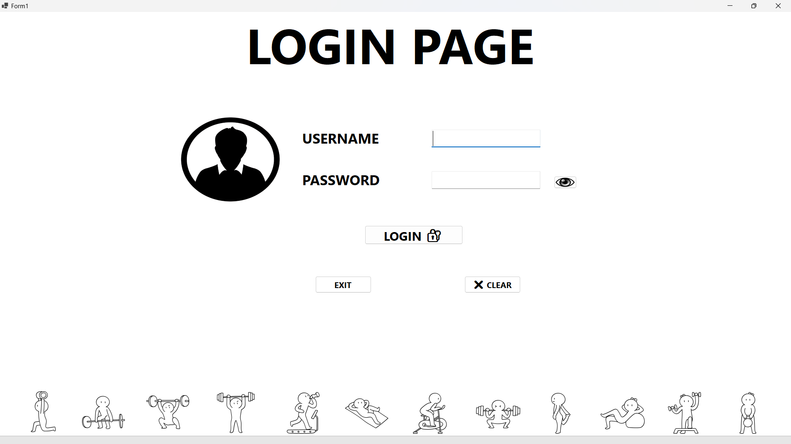

**Dashboard:**

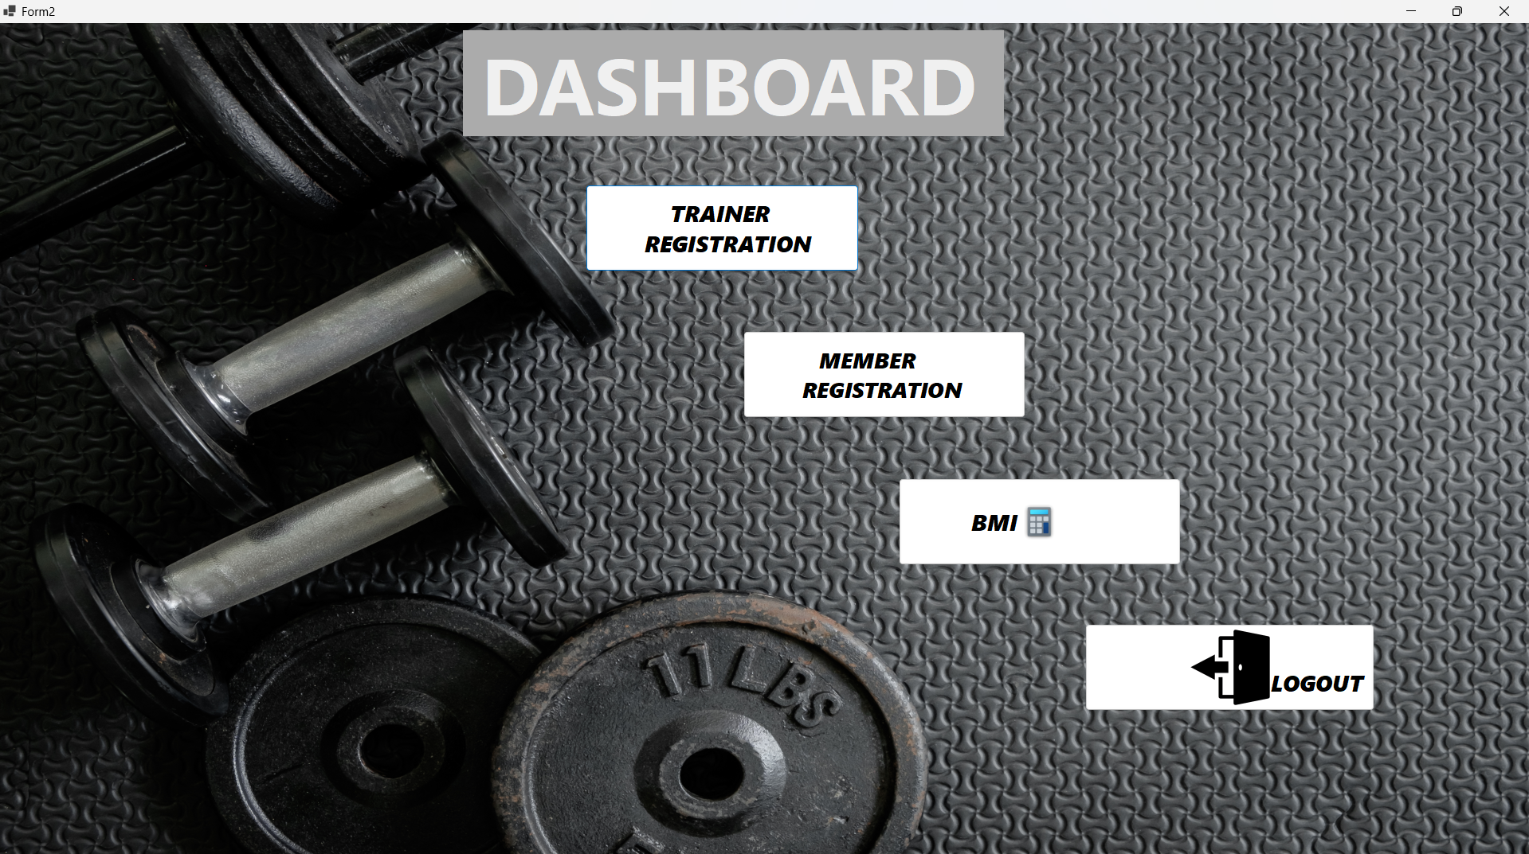

**Trainer Registration**

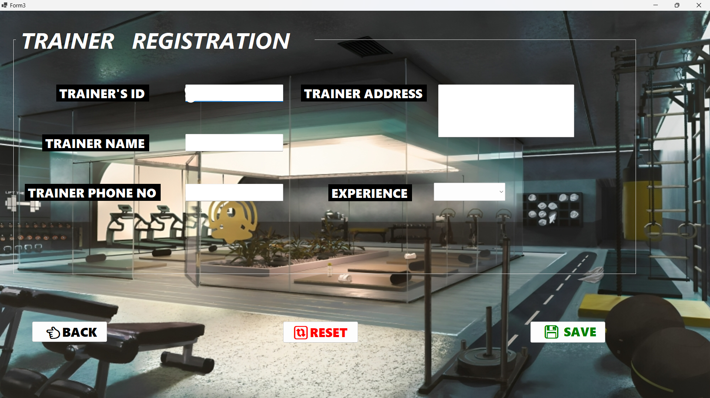

**Member Registration**

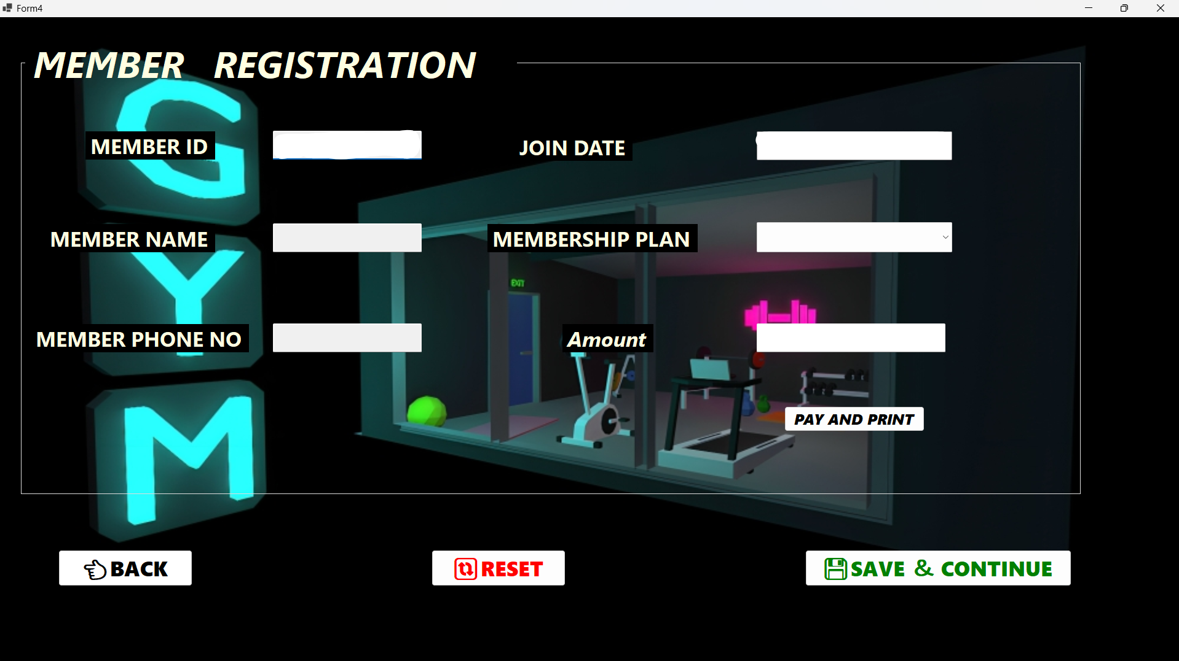

**BMI CALCULATOR**

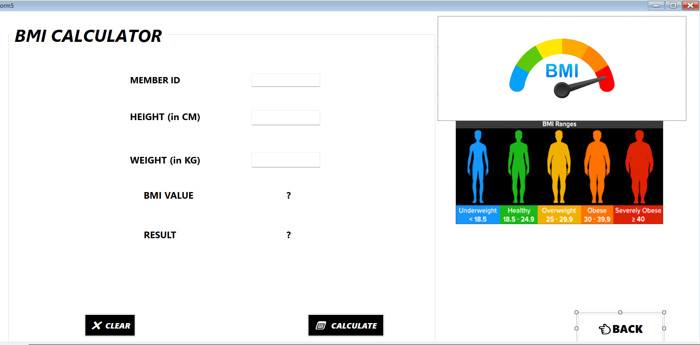

**CHAPTER 7:**

**TESTING**

**7. TESTING**

Software testing is the crucial element of the software quality assurance and represents the ultimate review of specification, design and coding. Testing represents an interesting anomaly for the software. During earlier definitions and development phases, it was attempted to build software from an abstract concept to tangible information. The testing phase is a very important phase since it is in this phase; we make sure that the system will perform the task without any error. Testing is vital to the success of the system and is being done by classifying it in two ways- System Testing and Program Testing. Program Testing involves checking the syntax and logic of the program. This checking resulted in achieving error free programs.

No matter how carefully a programmer designs and plans application, the programs are sure to have a few bugs in them. Errors in the program immediately stop program execution and display an error message if the errors are syntax errors. After debugging one can identify the limitations of this project and hence corrections are made. During the system development, each source code was tested for its level of correctness. Each form was run a number of times in order to ensure that the details are entered correctly and works properly.

**7.1 Test Plan**

Testing is the major quality control measure employed during software development. In the project, the first test considered is the unit testing. In this unit testing, each module of the system is tested separately. This is carried out during programming stage itself. Each module should work satisfactory as regard from the module. After the entire module are checked independently and completed then the integration testing is performed to check whether there is any interface errors. Then those errors are verified and corrected. And also, the security test is performed to allow only authorized persons to this system. Finally, the validation testing is performed to validate whether the customer requirements are stratified are not.

**7.2 Testing methodologies**

1. Unit Testing.
2. Output Testing.
3. Black-Box Test

**7.3 Unit Testing:**

Unit testing focuses verification efforts on the smallest unit of software design, the module. This is also known as “Module Testing”. The modules are tested separately. This testing is carried out during programming stage itself. In these testing steps each module is found to be working satisfactorily as regard to the expected output from the module.

This test can be considered as unit test. This has been carried out after the completion of one complete part. The word validation itself says about the nature of the test. Entire controls in the program have been tested in this manner. The limitations, nature and the boundaries are tested during the test. This test makes the work worthy to be developed further.

**7.4 Output Testing**:

After performing the validation testing, the next step is output testing of the proposed system since no system could be useful if it does not produce the required output in the specified format. The output generated or displayed by the system under consideration is testing asking the users about the format required by them. Here, the output is considered into two ways: one is on the screen and the other is printed format. The output format on the screen is found to be correct as the format designed according to the user needs. For the hard copy also, the output comes out as specified by the user. Hence output testing doesn’t result in any connection in the system.

**7.5 Integration testing**

The different modules are integrated as per the system design. The different modules are combined into subsystem and then tested to detect errors. The goal of the integration testing is to see if the modules can be integrated properly. It also involves interface testing.

**CHAPTER 8:**

**IMPLEMENTATION**

**8. IMPLEMENTATION**

Implementation includes all those activities that take place to convert from the old system to the new. The old system consists of manual operations, which is operated in a very different manner from the proposed new system. A proper implementation is essential to provide a reliable system to meet the requirements of the organizations. An improper installation may affect the success of the computerized system.

**IMPLEMENTATION METHODS**

There are several methods for handling the implementation and the consequent conversion from the old to the new computerized system. The most secure method for conversion from the old system to the new system is to run the old and new system in parallel. In this approach, a person may operate in the manual older processing system as well as start operating the new computerized system. This method offers high security, because even if there is a flaw in the computerized system, we can depend upon the manual system. However, the cost for maintaining two systems in parallel is very high. This outweighs its benefits. Another commonly method is a direct cut over from the existing manual system to the computerized system. The change may be within a week or within a day. There are no parallel activities. However, there is no remedy in case of a problem. This strategy requires careful planning. A working version of the system can also be implemented in one part of the organization and the personnel will be piloting the system and changes can be made as and when required. But this method is less preferable due to the loss of entirety of the system

**8.1 IMPLEMENTATION PLAN:**

The implementation plan includes a description of all the activities that must occur to implement the new system and to put it into operation. It identifies the personnel responsible for the activities and prepares a time chart for implementing the system. The implementation plan consists of the following steps.

* List all files required for implementation
* Identify all data required to build new files during the implementation.
* List all new documents and procedures that go into the new system

The implementation plan should anticipate possible problems and must be able to deal with them. The usual problems may be missing documents; mixed data formats between current and files, errors in data translation, missing data etc.

**POST IMPLEMENTATION REVIEW:**

After the system is implemented, a review should be conducted to determine whether the system is meeting expectations and where improvements are needed. System quality, user confidence and operating systems statistics are accessed through such technique event logging, impact evaluation and attitude surveys. The review not only assesses how well the proposed system is designed and implemented, but also is a valuable source of information that can be applied to a critical evaluation of the system.

The reviews are conducted by the operating personals as well as the software developers in order to determine how well the system is working, how it has been accepted and whether adjustments are needed. The review of the system is highly essential to determine the future enhancements required by the system. The system can be considered successful only if information system has met it objectives. The review analyses the opinion of the employees and identifies the attitudes towards the new computerized system. Only when the merits and demerits of the implemented system are known, one can determine what all additional features it requires are. The following are the issues to be considered in the evaluation of the system.

* + The change in the cost of operation after the installation of the computerized system.
  + The basic change that has been affected after the introduction of the system.
  + The improvement in the accuracy of the computations.
  + The acceptance of the new system by the staff and the convenience it brought to them.
  + The change in the effectiveness caused by the implementation of the new system.

A study of the system has revealed that the employees due to the user friendliness have accepted the system, reduced the number of errors, increased accuracy and decreased cost of operations. The system also pays for efficient and speedy execution of operations compared to the earlier system.

**CHAPTER 9:**

**CONCLUSION AND FUTURE ENHANCEMENT**

**9. CONCLUSION AND FUTURE ENHANCEMENT**

the Gym Management System developed using VB.NET offers a robust platform for admin users to efficiently manage various aspects of a gym facility. Through forms like login, dashboard, trainer registration, member registration, and BMI calculator, the system provides a seamless experience for overseeing trainers, members, and health metrics. The login form ensures secure access, while the dashboard acts as a central hub for navigating functionalities. Trainers and members can be easily registered, and BMI calculations provide health insights for members, fostering a holistic approach to fitness management within the gym environment.

In the future, your gym management system could be enhanced in several key areas to offer an even more comprehensive and user-friendly experience. Firstly, implementing role-based access control would provide different levels of access for administrators, trainers, and members. This could ensure that sensitive information is only accessible to authorized personnel while empowering trainers and members with appropriate functionalities tailored to their needs. Additionally, integrating an attendance tracking system could enable administrators and trainers to monitor member engagement effectively, allowing for more informed decision-making regarding class schedules and resource allocation.

Another significant enhancement could involve the integration of a payment processing system. By streamlining financial transactions within the system, this feature would offer convenience for both administrators and members, with options for online payments, invoicing, and automatic billing. Moreover, developing a scheduling and booking system for trainers and classes would greatly enhance the user experience. Members would appreciate the ability to book appointments and reserve spots in classes seamlessly through the system, improving satisfaction and engagement levels.

Furthermore, implementing fitness progress tracking functionalities could empower members to monitor their fitness journeys more effectively. This feature could include tools for setting goals, recording workouts, tracking measurements, and generating progress reports. By providing members with the means to track their progress comprehensively, the system would contribute to increased motivation and adherence to fitness goals. Overall, these enhancements would elevate your gym management system to better meet the evolving needs of administrators, trainers, and members, fostering improved efficiency and satisfaction across the board.

**CHAPTER 10:**

**BIBLIOGRAPHY**

**10. Bibliography**

Francesco Balena 2002. Programming Microsoft Visual Basic .NET, US: Microsoft Press.

Anne Boehm 2012. Murach's VB.NET, US: Mike Murach & Associates, Inc.

Bill Sheldon, Billy Hollis, Rob Windsor, David McCarter, Gastón C. Hillar, Todd Herman 2010. Professional Visual Basic 2010 and .NET 4, US: Wiley Publishing, Inc.

Evangelos Petroutsos 2010. Mastering Microsoft Visual Basic 2010, US: Sybex.

Deborah Kurata 2013. Doing Objects in Visual Basic 2005, US: Addison-Wesley.

**YouTube links**

1.https://www.youtube.com/watch?v=Vx_U7gj4syU

2.https://www.youtube.com/watch?v=-q4HT-od9ds

**Websites**

1.https://en.wikipedia.org/wiki/SQL_Server_Management_Studio

2.https://en.wikipedia.org/wiki/Visual_Studio

**CHAPTER 11:**

**APPENDICES A**

**APPENDICES A**

**Tables Structure**

**Trainer Registration**

|  |  |  |  |
| --- | --- | --- | --- |
| **Field name** | **Data type** | **Description** | **Constraints** |
| Trainer id | int | Unique ID for each Trainer | Primary key |
| Trainer name | varchar(50) | Name of Trainer | NOT NULL |
| Trainer Phone no | numeric(10, 0) | Phone number of Trainer | NOT NULL |
| Trainer address | varchar(60) | Address of Trainer | NOT NULL |
| Experience | varchar(50) | Trainer’s Experience | NOT NULL |

**Member Registration**

|  |  |  |  |
| --- | --- | --- | --- |
| **Field name** | **Data type** | **Description** | **Constraints** |
| Memberid | int | Unique ID for each Member | Primary key |
| Member name | varchar(50) | Name of Member | NOT NULL |
| Member phone no | numeric(10, 0) | Phone number of Member | NOT NULL |
| Join date | date | Joining date of Member | NOT NULL |
| Membership plan | varchar(50) | Membership plan for member | NOT NULL |
| amount | int | Fees for member | NOT NULL |

**BMI Calculator**

|  |  |  |  |
| --- | --- | --- | --- |
| **Field name** | **Data type** | **Description** | **Constraints** |
| Memberid | int | Unique ID for each member | PK,FK |
| HEIGHT(in cm) | varchar(50) | Height of the member | NOT NULL |
| WEIGHT(in kg) | varchar(50) | Weight of the member | NOT NULL |
| BMI value | varchar(50) | Bmi value of the member | NOT NULL |
| Result | varchar(50) | Bmi result of the member | NOT NULL |

**CHAPTER 11:**

**APPENDICES B**

**SCREENSHOTS**

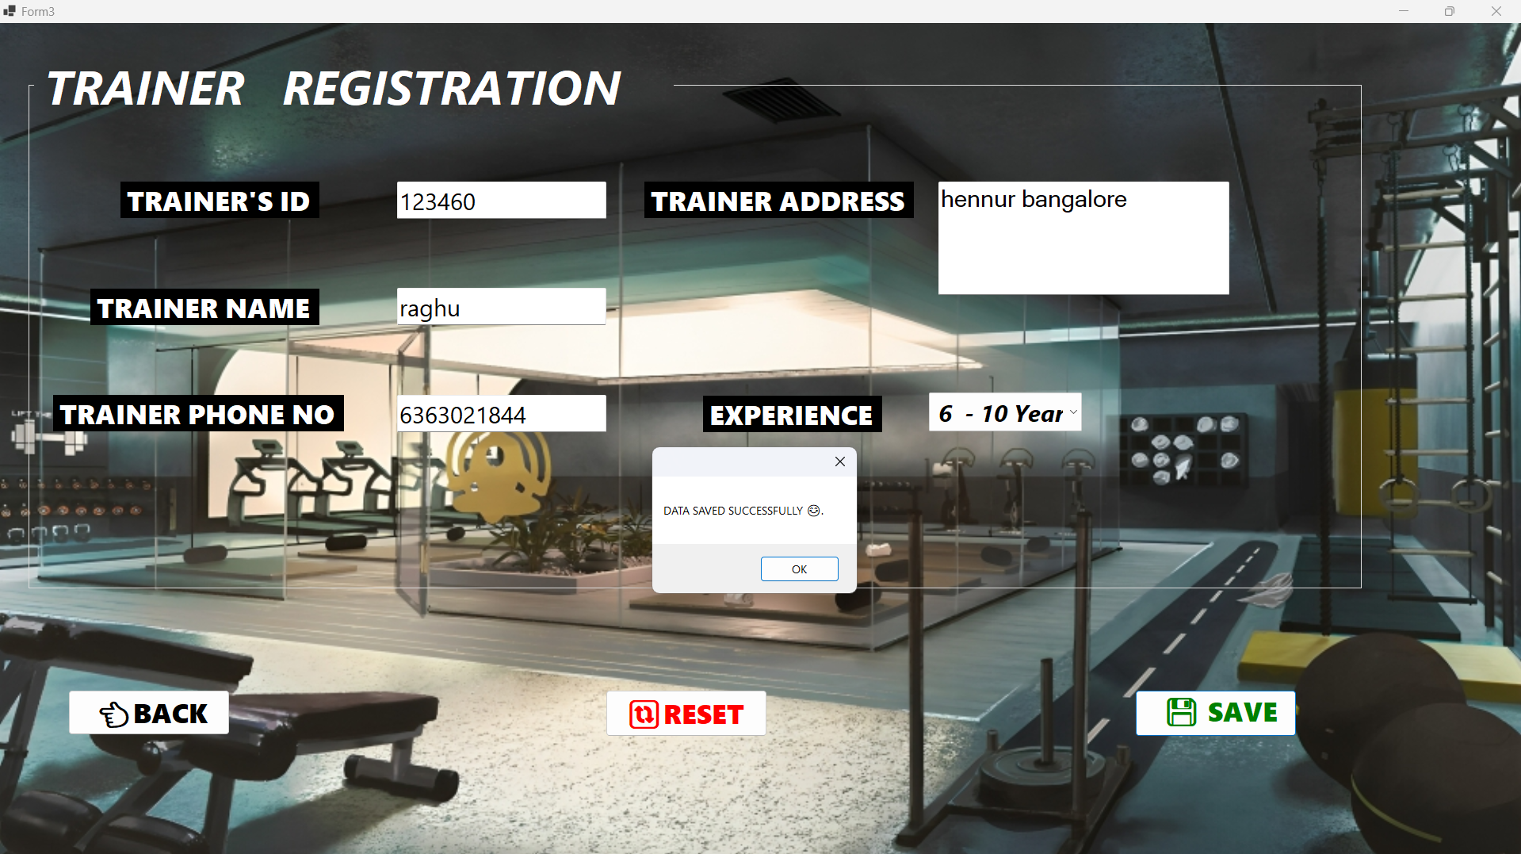

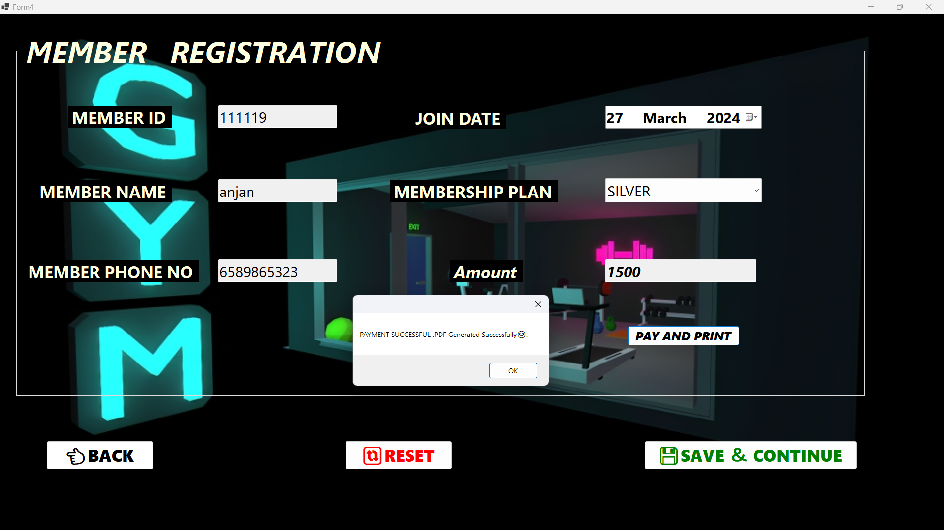

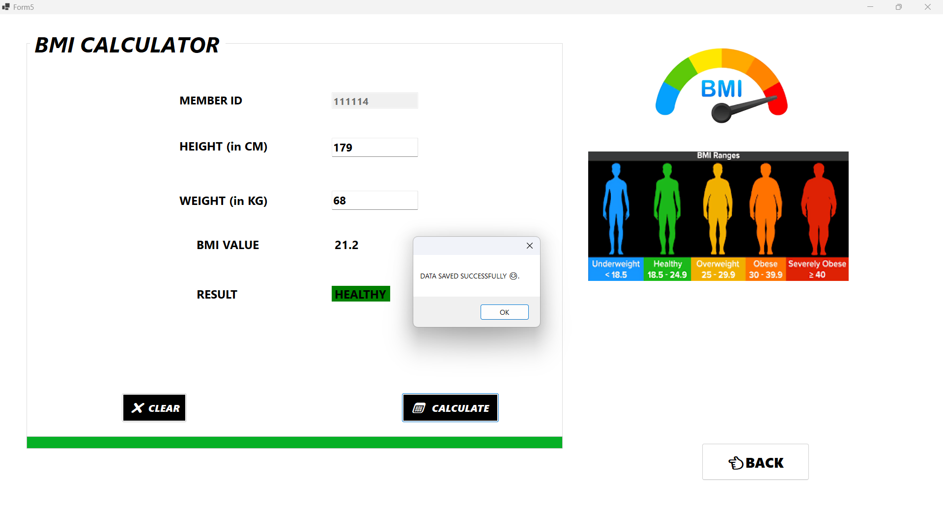

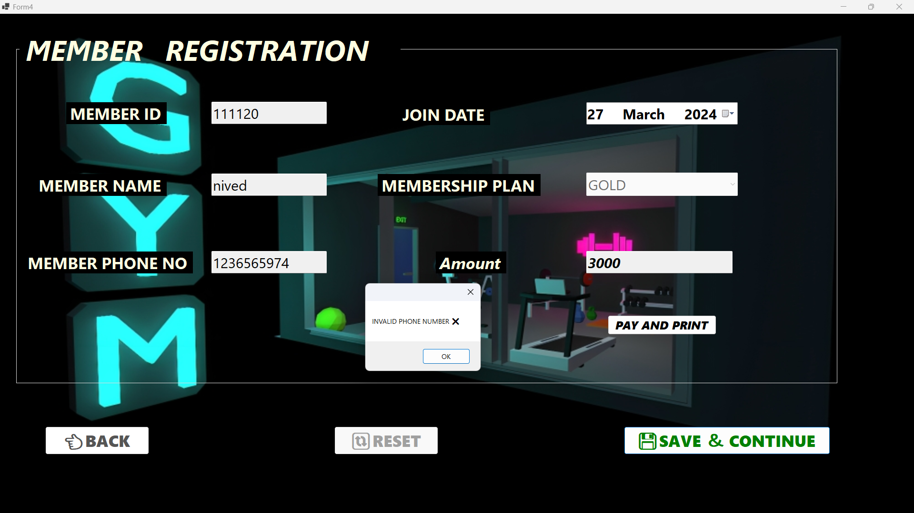

**CHAPTER 11:**

**APPENDICES C**

**SAMPLE REPORT OF TEST CASES**

**11. Test cases**

|  |  |  |  |  |  |  |  |
| --- | --- | --- | --- | --- | --- | --- | --- |
| **Project Name** | **Gym Management System** | | | | | | |
| **Module Name** | **Admin Login, Trainer Registration, Member Registration, BMI Calculator** | | | | | | |
| **Test**  **Reviewed By-** | **Prof. Simmi S** | | | | | | |
| **Requirements ID** | **Test Case ID** | **Test Name** | **Test**  **Prerequisites** | **Form** | **Expected Result** | **Actual Result** | **Test Status** |
| Admin Login | TC_1 | Login | Valid user name valid password | Login Form | Login Successful | Login Successful | Pass |
| Admin Login | TC_2 | Login Wrong credentials | Invalid Username and password | Login Form | Unsuccessful  Login | Invalid Username or Password | Pass |
| Trainer Reg | TC_3 | Trainer Registration | Valid trainer details | Trainer  Registration  form | Trainer Registration | Trainer  Registered Successfully | Pass |
| Trainer reg | TC_4 | Trainer Registration  With Empty field | Trainer is not registered | Trainer  Registration  Form | Error Message | Please fill in all the required field | Pass |
| Trainer reg | TC_5 | Trainer registration  with invalid phone no | Invalid phone no | Trainer Registration  form | Error Message | Invalid input | Pass |
| Trainer Reg | TC_6 | Trainer phone no With same number | Invalid Phone No | Trainer Registration  form | Trainer already registered | Invalid input | Pass |
| Trainer Reg | TC_7 | Trainer with same id | Invalid Trainerid | Trainer Registration  form | Trainer already  exists | Error message | Pass |
| Member Reg | TC_8 | member Registration | Valid Member details | Member Registration  Form | Member  Registration | member  Registered Successfully | Pass |
| Member Reg | TC_9 | Member Registration  With Invalid Joindate | Member joindate should be present date | Member Registration  Form | Error Message | Joindate cannot be in the future | Pass |
| Member Reg | TC_10 | Payment Generation with unregistered Member id | Member id which is not registered | Member Registration  Form | Error message | Member is not registered | Pass |
| Member Reg | TC_11 | Member phone no With same number | Invalid Phone No | Member Registration  Form | Member already registered | Invalid input | Pass |
| Bmi value | TC_12 | Calculate without details filled | Bmi is not calculated | Bmi calculator  form | Fill the details | Should fill the required field | Pass |
| Bmi value | TC_13 | Without calculating going back | Fill the deatils | Bmi calculator  form | Error message | Please calculate your bmi | Pass |
| Bmi value | TC_14 | invalid height  entered | Invalid Height | Bmi calculator  form | Error message | entered value should be between 100 to 250 | Pass |
| Bmi value | TC_15 | invalid weight  entered | Invalid Weight | Bmi calculator  form | Error message | entered value should be between 30 to 250 | Pass |